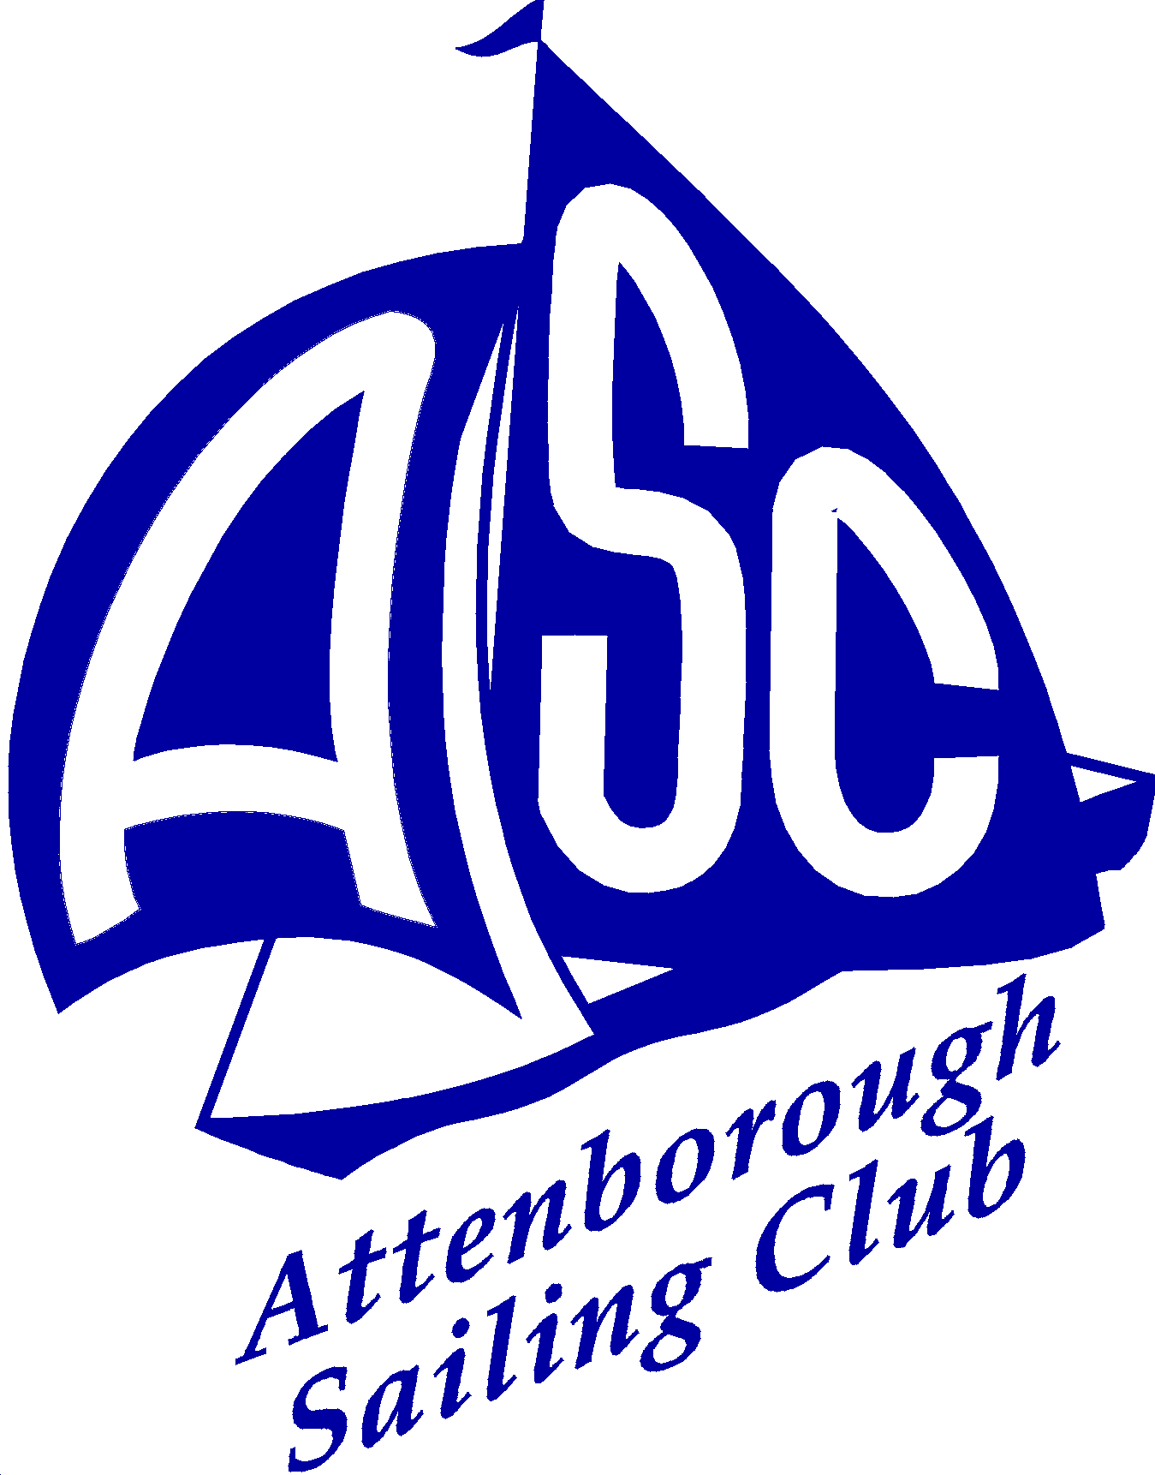
New Application for Membership 2017
Attenborough Sailing Club

PRIMARY CONTACT DETAILS (For a Junior application this section should be completed by an adult with legal Parental Responsibility)
Title: | First Name: | Family Name:
Address: |  |  |  | Postcode:
Home phone No: |  |  | Mobile phone No:
Email:
ADDITIONAL MEMBERS’ DETAILS covered by the membership; giving the date of birth of anyone aged under 18:
First Name | Family Name | Email | Mobile | DoB
Membership Fees
Membership Fees (1st January to 31st December 2017) * | £/Annum | Quantity | Total
Family Member (two adults and all their children up to age 18) | £105.00
Full Member (adult over the age of 17) | £90.00
Veteran Family Member (as for Family Membership, except that the senior adult must be over the age of 65) | £90.00
Veteran Full Member (adult over the age of 65) | £75.00
Junior Member (person over the age of 14 and under the age of 18) | £25.00
Student Member (adult over the age of 18, in full time education with a valid Student’s Union membership) | £35.00
Social Member (Non-sailing category of membership suitable for parents/guardians of juniors) | £30.00
Key Deposit | £10.00 | One | £10.00
Boat Permit Fee(s) (payable for each boat stored at Attenborough SC) | £30.00
Total

- Where the membership is to commence after 1st August, the annual fee is halved and any boat permit fees are also halved.

- Please describe your main reasons for wishing to join the Attenborough Sailing Club :
Boat Details
Boat owning members shall at all times have third party insurance cover of not less than £2,000,000 for any one accident. No boat may participate in sailing from the Club premises unless it satisfies the conditions of boat buoyancy laid down by the relevant Class Association. Please give boat details below (if applicable). Once your membership has been accepted you will be allocated boat-parking space, if required, by the membership secretary.
 | Boat 1 | Boat 2 | Boat 3
Class of Boat
Sail Number
Insurance Company
Policy Number

Other Information

Does anyone covered by this application hold any recognised RYA sailing / boating qualifications?
Dinghy Sailing: |  | Powerboat |  | First Aid |  | Other relevant skills/qualifications
Level 1 |  | Level 1 |  | RYA approved
Level 2 |  | Level 2 |  | 1st aid @ work (FAW)
Instructor |  | Safety |  | 1st aid @ work (EFAW)
Coach |  | Instructor |  | 1st aid Trainer

Please describe any non-sailing skills, which you may be willing to contribute to the club (for example: catering, electrical, building, plumbing, book keeping, secretarial, grass cutting, IT, sign writing, etc.)

Are you known to any existing members of the Attenborough Sailing Club?
- Yes Name/s:
❑ No If you are unknown to a member then you will be contacted by an officer of the club who will discuss your application with you and discuss race duty responsibilities, insurance requirements, boat parking, use of club boats, etc.
Declaration
I wish to apply for membership of Attenborough Sailing Club.
My boat(s) will carry third party insurance cover to a minimum of £2,000,000.
I am aware that the rules require all members to carry out sailing duties and I am willing to do so.
I have no objection to club records being kept on a computer for club use.
I have no objection to my contact details being published in club yearbook or the club keeping me up to date with club related news via either post or email.

Signed: Date:

Cheques should be made payable to Attenborough Sailing Club. Please return the completed form, with your remittance, to:

Roger Chilvers, Membership Secretary, 3 Dunster Road, West Bridgford. Nottingham, NG2 6JF
Phone 07981 655007; e-mail roger.chilvers@yahoo.co.uk or membership@attenboroughsc.org.uk

Your application will be posted on the Club Notice Board and will be considered at the next meeting of the Committee. If elected you will receive a welcome pack including club compound and gate keys and a club yearbook inclusive of the club rules. In the unlikely event that your application is rejected, your fee will be refunded.
Attenborough Sailing Club is an affiliate member of the RYA and an RYA recognized teaching establishment www.attenboroughsc.org.uk

Membership applications must be submitted with a cheque for the required amount
Applicants are welcome to use the Club’s facilities whilst the application is being progressed.

